# Update May 3rd

## LAI-comparison

Processing:

* extract bimonthly means from daily LAIre
* statistical comparison (correlate, linear Regression)
* Compare LSP
  + Difference (SOS, GSL)
  + Decadal change (GSL change in days / 10 years)

Findings:

* raw data fits well (R around 0.8 for all months)
* extracted LSP fits well in certain regions (i.e. NOT in tropics)

e.g. SOS difference (SOSLAIre-SOSLAI3g for 1987):

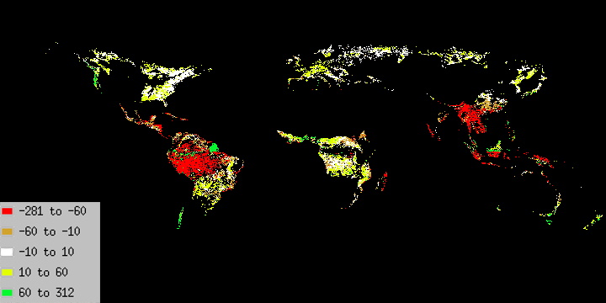

* decadal change:

LAI3g:

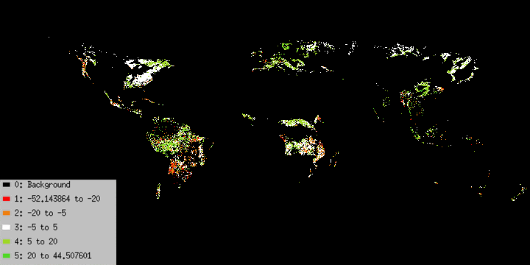

LAIre:

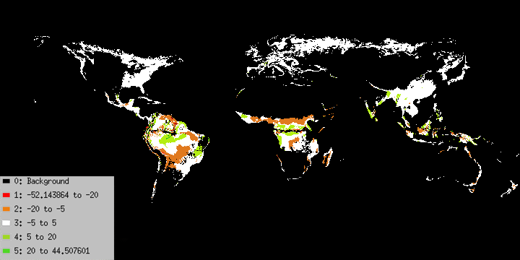

## Climatic Controls

Processing:

* extraction from LAIre dataset and bimonthly averaging
* decadal change
* yearly „dominance“ per pixel
  + change-map (in progress)

decadal change:

brown/red: it got hotter, temperature less of a constraint

green tones: it got colder / more of a restraint

Temperature control change for May:

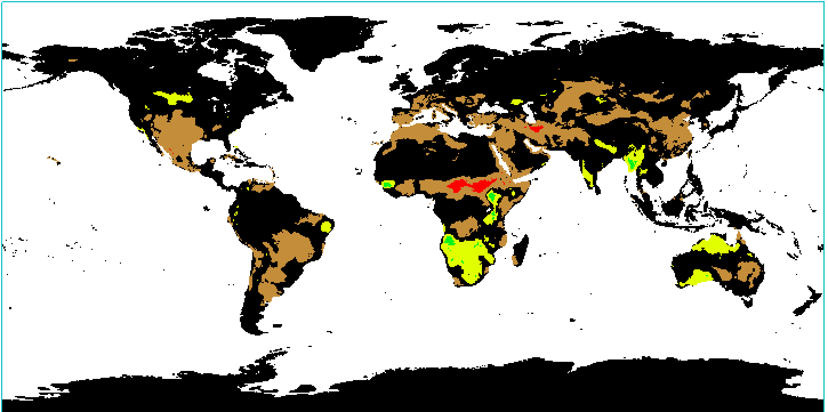

Temperature control change for October:

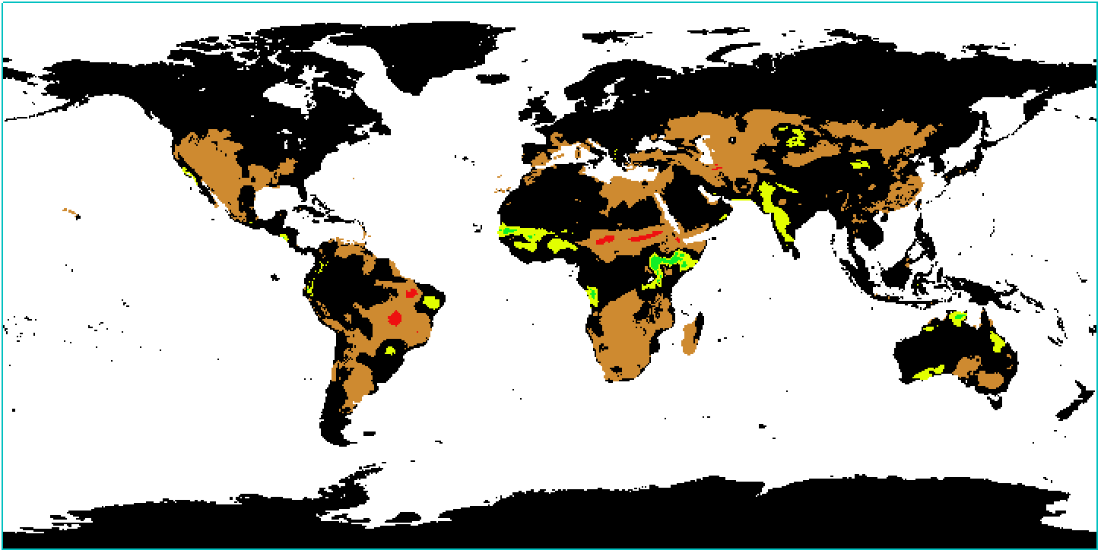

brown/red: drying, lack of moisture more important as a control

green tones: more moisture, less of a factor

Moisture control change for May:

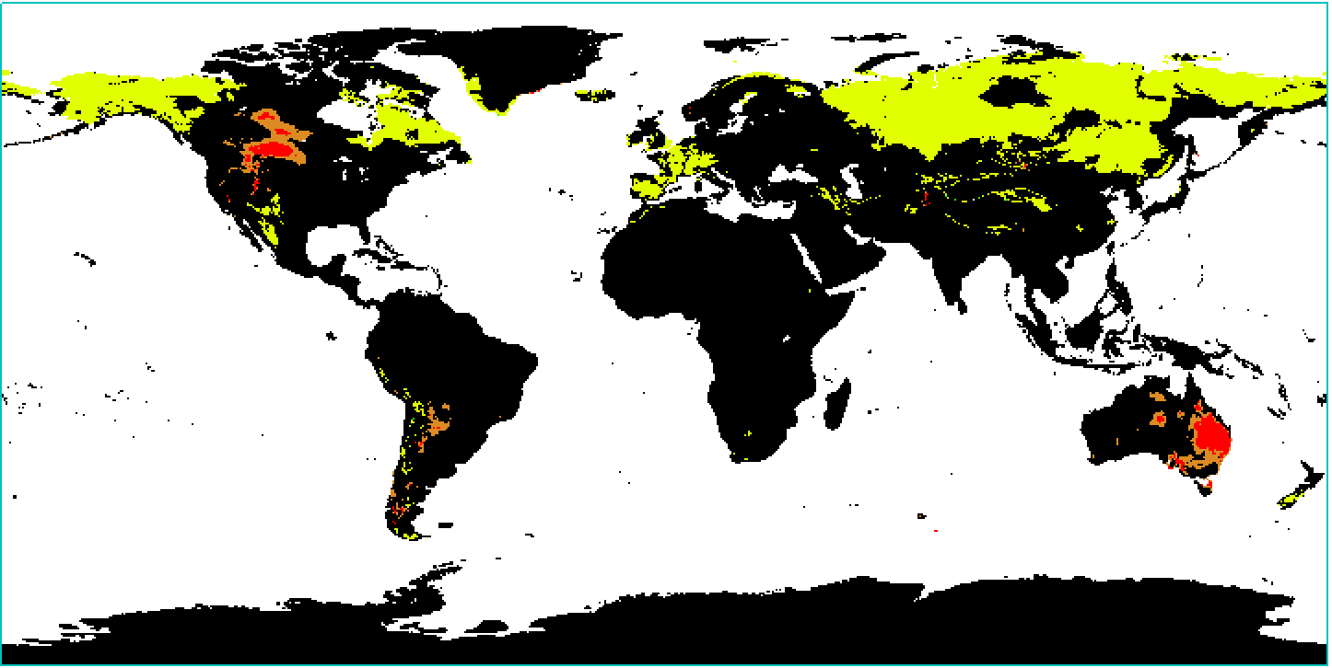

Moisture control change for October:

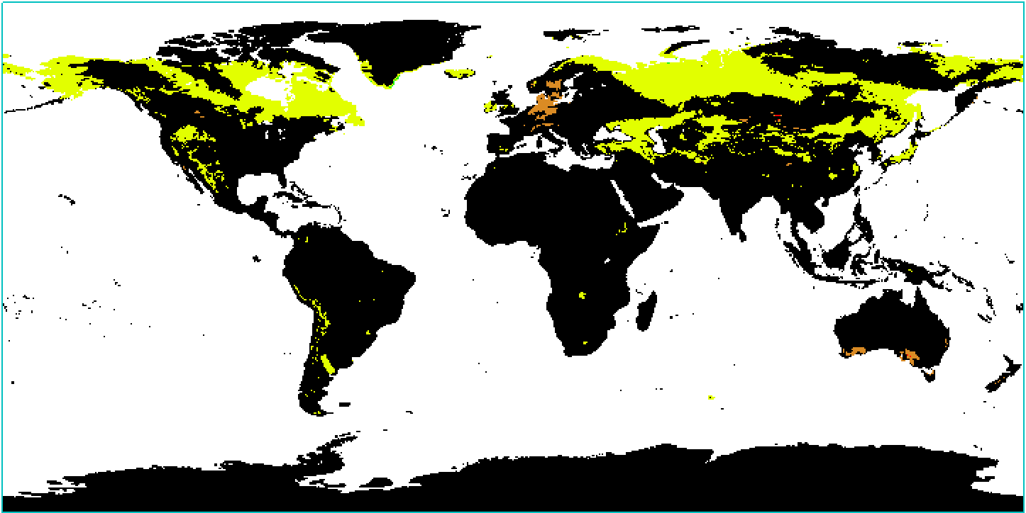

Yearly dominating factor: parameterization problem in LAIre?

Temperature,

Moisture,

Light

1982:

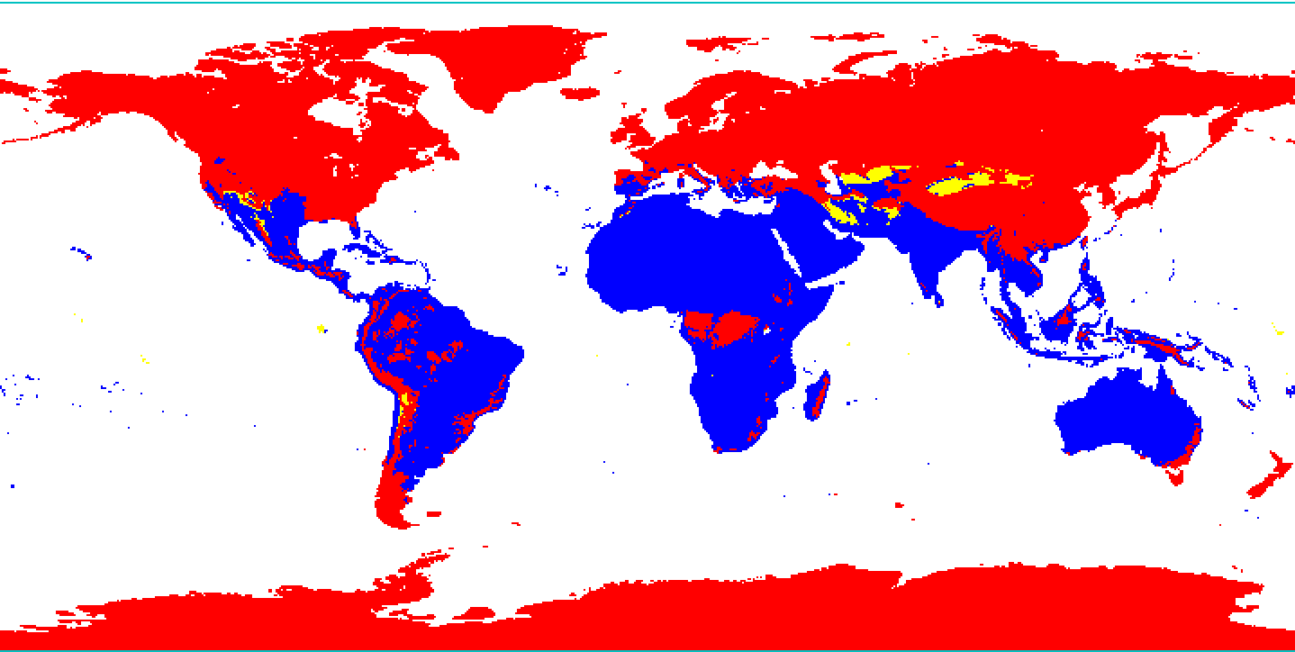

1983 (and later):

